

**02 kuNhlolanja 2025**

**UMBIKO OKHISHWA NGOKUPHUTHUMA**

**iSIMANGALISO WETLAND PARK SIBUNGAZA USUKU LWAMAXHAPHOSI**

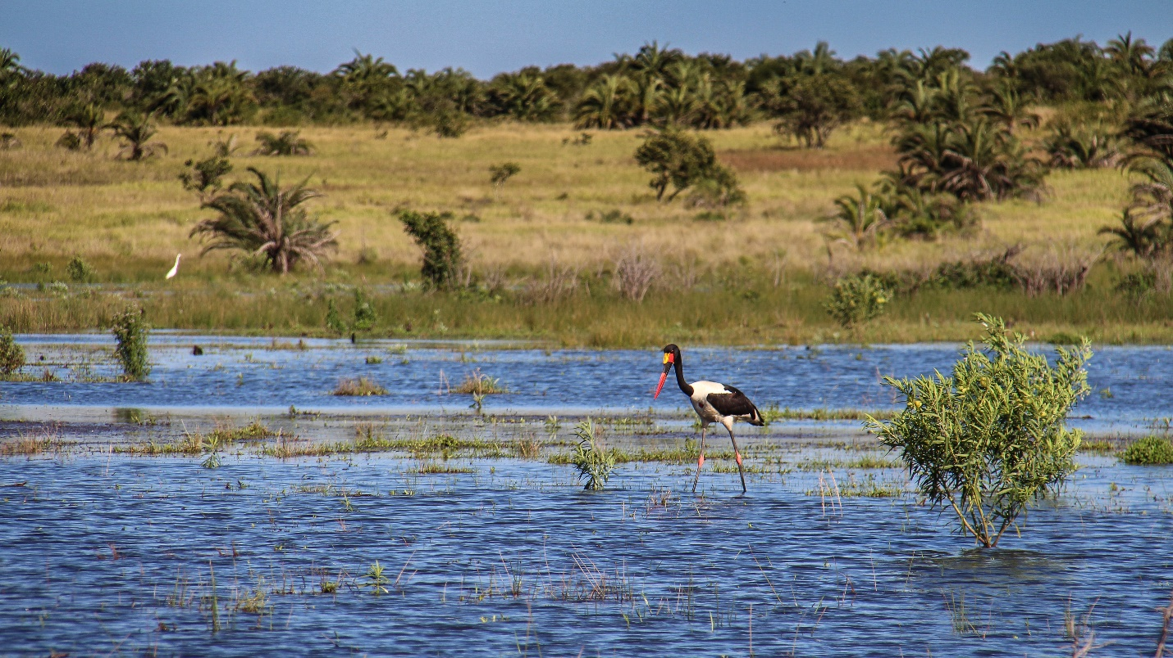

iSimangaliso Wetland Park siyakuthakasela ukubungaza usuku lwamaxhaphosi, okuwukuthi lolu usuku olubungazwa ngomhlaka-2 kuNhlolanja minyaka yonke. Njengoba iSimangaliso kuyinhlangano eyaziwa umhlaba wonke, samukela isiqubulo sakulo nyaka ka-2025 esithi, ‘’Kuvikelwa amaxhaphosi angomuso’’. Inhloso yalolu suku ukufundisa nokuxwayisa kuzo zonke izingxenye zomphakathi, mayelana nokubaluleka kanye nomsebenzi owenziwa ngamaxhaphosi, ukusebenza kwawo kanye nokubaluleka kwawo kwimvelo. Lokhu kuhambisana nenhlosongqangi okuwukuthi umphathi omkhulu weSimangaliso Wetland Park unayo ngePaki, okufakazela lokho ukubambisana okukhona phakathi kweSimangaliso kanye ne-*WildTrust* ukuze kusabalaliswe umlayezo emphakathini ukuze kugqugquzeleke ubunye ekongiweni kwemvelo kanye nezindawo ezivikelwe (MPA).

Lolu suku lubiza ukuthi uhulumeni, izinhlangano kanye nawo wonke umuntu ophilayo ukuba athathe izinyathelo ukuze kuvikeleke amaxhaphosi. Ngokwenhlangano ebizwa ngokuthi yi-*United Nations* *(UN),* amanzi ahlanzekile okufaka phakathi atholakala emfuleni, emachwebeni njalo njalo aneqhaza elikhulu emiphakathini, ezimbonini kanye nasekugcinweni kwamasiko athile. Lapha kula maxhaphosi kutholakala amanzi angenawo usawoti, alekelela kakhulu kwimvelo, aphinde asize ukuthi kunciphiseke isimo sokuguquguquka kwesimo sezulu njengoba amaxhaphosi eyimvelo ekwazi ukwenza lokho, ephinde enciphise amazinga okuthi kube nezikhukhula kanye nokuwa kwamatshe.

Amaxhaphosi lapha eNingizimu Afrika alinganiselwa kumaphesenti angu*-2.4%*. Ngenxa yokuthi kunezimo ezahlukene eziphazamisa ubukhona bamaxhaphosi, kube sekwehla inani lamaxhaphosi akhona kuleli lizwe, okuwukuthi isizathu esikhulu ukuthi ngaphandle kokuguguguquka kwesimo sezulu, kunengcabha ekuvikelweni kwamaxhaphosi. Angamaphesenti ayishumi nanye nje vo amaxhaphosi avikelwe kahle kuleli laseNingizimu Afrika, okuwukuthi alinganiselwa kumaphesenti angamashumi ayisikhombisa okubukeka engavikelwe nhlobo. ENingizimu Afika kunamaxhaphosi angamashumi amathathu azeka umhlaba wonke, abizwa ngokuthi amaxhaphosi abaluleke ngokusezingeni lomhlaba (RAMSAR sites). iSimangaliso Wetland Park, sona sinamane, okusho ukuthi sinendawo enamaxhaphosi amakhulu kuleli lase Ningizimu Afrika. Lama xhaphosi abaluleke ngokusezingeni lomhlaba angaphansi kweSimangaliso Wetland Park yilawa alandelayo; St Lucia Lake, Lake Sibaya, uMgobozeleni kanye neKosi Bay Lakes, eKosi Bay ahlukaniseke kane okuyilawa; Amanzimnyama, Nhlange, Mpungwini kanye naseMakhawulani.

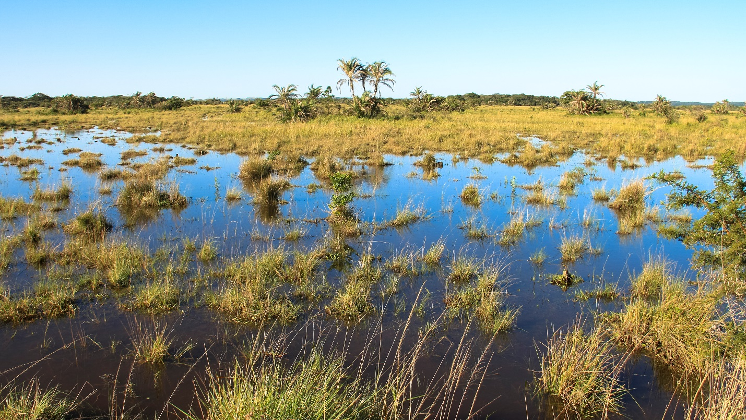

iSimangaliso Wetland Park sike sabhekana nezinselelo ezahlukene mayelana nokubhekelela lamaxhaphosi abaluleke ngokusezingeni lomhlaba, izinselelo eziningi bezibhekene nechweba laseSibaya. Leli chweba yilona elikhulukazi kuleli elinamanzi ahlanzekile angenawo usawoti. Lazeka kakhulu ngokuba nemvelo ehlukahlukene ephila khona kanye nezilwane nezihlahla zendabuko.

Okubi okwenzeka kula machweba ukuthi amanzi alokhu ehla kusuka ngonyaka ka-2001, ngenxa yesimo sokuguquguquka kwesimo sezulu kanye nokusebenziseka kwendawo. Amanzi echweba wona ahlukile ngoba uma kuna imvula imifula ithelela khona. Ngakho-ke, ichweba lona lithola amanzi uma kuna imvula, okuwukuthi lokho bekungenzeki kahle kule minyakana embalwa edlule. Abalimi abahwebayo kanye nalabo abalimela ukuthi bedle nabo babe nesandla ekutheni kwehle amanzi ngoba baba nezindlela zokuthi bedonse amanzi echwebeni eze emasimini abo. Ukubhekana nalokhu, iSimangaliso sisebenzisane nababambe iqhaza abafana ne-*SAEON*, ukuze kuzobhekwa ukusebenza kwechweba inyanga nenyanga, okuwukuthi kuzokalwa kubhekwe amanzi avela makuna imvula kanye nalawo asuka phansi. Kuphindwe kwasetshenziswana nabanye ukuze kuzanywe ukulungisa isimo sokusebenza kwechweba ukuba sibuyele esimeni esijwayelekile.

Kuningi umuntu akangakwenza ukubungaza lolu suku olubaluleke kangaka. Ungafundisa abanye ugxile kwiqhaza lamaxhaphosi kwimvelo, okanye ube ingxenye yokufunda okusezingeni elithe thuthu mayelana nokufunda ngamaxhaphosi kanye nazo zonke izindawo ezivundile uphinde ulandelele ekutheni imvelo yona ilindele ukuthi siyiphathe kanjani yona, kumbe ube nohambo lapho uzohambisana nongoti ozokuchazela kabanzi ngemvelo kanye nezihlahla nezinyoni njalo njalo. Lapha eSimangaliso yindawo enhle kakhulu enezinyoni ezahlukene ezithokozelwa abavakashi. Ezikoleni, othisha bengahlela ukuthi kube nomcintiswano wokudweba lapho kuzogqugquzeleka abafundi ukuba babe nentshisekelo ngemvelo amalungu emiphakathi wona angahlela ukukhuculula amaxhaphisi ukuba abe sesimeni esihle.

NgoMsombulukowangomhlaka-3 kuNhlolanja 2025, mayelana nokubungaza lolu suku, iSimangaliso Wetland Park kanye nababambe iqhaza bavakashele isikole samabanga aphansi iKhiphinkunzi Primary School okuyisikole esakhelene nePaki. Lapha bekufundiswa abafundi mayelana nokubaluleka kwalolu suku, abafundi babe neqhaza elikhulu ekuphumeleleni kokubungaza kwalolu suku, usuku olukhulu kakhulu lolu kubafundi ngoba izingane ezincane izona eziyikusasa laleli lizwe, ngalokho uma kuhlwanyelwa imbewu enhle kuzo, izothela izithelo ezinhle ngomuso.

**-Iyaphela-**

**Isitatimende sikhishwe iSimangaliso Wetland Park Authority**

**Abezindaba bengaxhumana no:**

MLO: Mr Bheki Manzini

Call/WhatsApp: 060 533 2082

Email: bhekimanzini@isimangaliso.com