**13 kuZibandlela 2024**

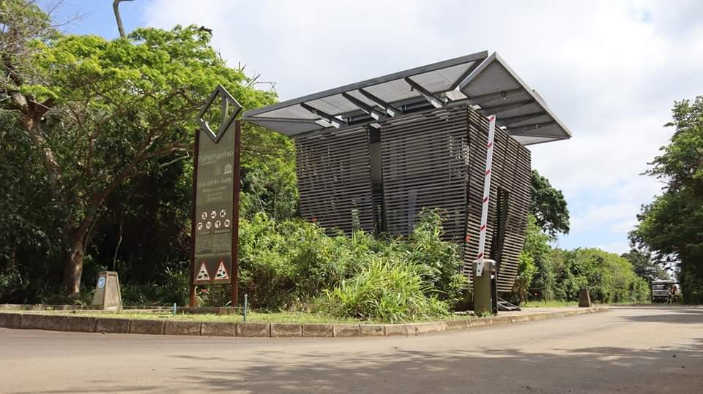**Imali yokungena emagedeni eSimangaliso Wetland Park kunyaka ka-2024-2025**

Sekuyileso sikhathi sonyaka lapho iSimangaliso Wetland Park Authority’s sibuyekeza imali yokungena emagedeni minyaka yonke. Izindaba ezimnandi ezokuthi ibhodi leSimangaliso ligunyaze ukuthi imali ekhokhwa abavakashi bakuleli laseNingizimu Afrika ingashintshwa bese kuba nezinguquko ezincane kubavakashi abavela kumazwe omhlaba ukuhambisana nezinga lokushintshisana ngomnotho. Kwavunyelwana ngo elethu kuleso sinqumo, njengoba ibhodi likholelwa ekutheni ukuze ezokuvakasha zizoba nozinzo, kumqoka ukuthi kubhekwe isimo somnotho wezwe kuphindwe kubhekwe ukuthi lokho kungaba namthelela muni kubavakashi labo iSimangaliso esihlose ukubaheha ngasikhathi sonke kungeve kuwukuthi bahehelwa ngesikhathi samaholidi kuphela. Ibhodi liphathiswe umsebenzi wokuqinisekisa ukuthi kuyangeneka emagedeni eSimangaliso Wetland Park ngaso sonke isikhathi, ikakhulukazi imiphakathi engathathi ntweni eyakhelene nePaki. Phambilini ngonyaka ka-2023/2024, kwanyuswa ngamaphesenti ayisihlanu nje vo.

Njengobufakazi bokuphatha kahle, iSimangaliso siphinde sathola umbiko ongenagcobho kumcwaningi mabhuku waseNingizimu Afrika ngesabelomali sika 2023/2024. Lokhu sekwenzeke izikhawu ezimbili kulandelana. “Kuhlezi kumqoka ukugcina iSimangaliso Wetland Park sakha inzuzo kodwa ngakolunye uhlangothi kumele kuqinisekiswe ukuthi akuhlalwa entanyeni kubantu”, kusho umphathi omkhulu weSimangaliso Wetland Park Authority, uMnuz. Sibusiso Bukhosini.

 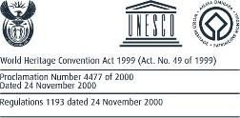

Isazizo ngokunyuka kwemali yamaphemithi kusuka ngomhlaka

01 kuZibandlela 2024 - 30 kuLwezi 2025

|  |  |  |  |  |
| --- | --- | --- | --- | --- |
| **Gate fees** | **Adult** | **Children** | **International** | **Children** |
| Eastern Shores (Bhangazi Gate) | R 62,00 | R 45,00 | R 130,00 | R 95.00 |
| uMkuze (Ophansi and eMshopi Gates) | R 62,00 | R 45,00 | R 130,00 | R 95.00 |
| Western Shores (Dukuduku & Nhlozi Gates) | R 62,00 | R 45,00 | R 130,00 | R 95.00 |
| Sodwana Bay | R 34,00 | R 21,00 | R 71.00 | R 50 |
| Maphelane | R 57,00 | R 34,00 | R 120.00 | R 71.00 |
| False Bay | R 57,00 | R 34,00 | R 120.00 | R 71.00 |
| Coastal Forest | R 34,00 | R 23,00 | R 71.00 | R 50.00 |
| Kosi Bay | R 34,00 | R 23,00 | R 71.00 | R 50.00 |

|  |  |  |  |  |
| --- | --- | --- | --- | --- |
| **Vehicles Fees** | **Cc-1-5** | **Cc-6-12** | **Cc-13-20** | **Cc21+** |
| Eastern Shores (Bhangazi Gate) | R 74,00 | R 108,00 | R 147,00 | R 250,00 |
| uMkuze (Ophansi and eMshopi Gates) | R 74,00 | R 108,00 | R 147,00 | R 250,00 |
| Western Shores (Dukuduku & Nhlozi Gates) | R 74,00 | R 108,00 | R 147,00 | R 250,00 |
| Sodwana Bay | R 30,00 | R 57,00 | R 80,00 | R 130,00 |
| Maphelane | R 27,00 | R 29,00 | R 29,00 | R 29,00 |
| False Bay | R 29,00 | R 34,00 | R 40,00 | R 46,00 |
| Coastal Forest | R 40,00 | R 40,00 | R 40,00 | R 46,00 |
| Kosi Bay | R 40,00 | R 40,00 | R 40,00 | R 46,00 |



|  |  |  |
| --- | --- | --- |
| **New Vessel/ Launch Fee** | **Cc-2025** | **Comment** |
| Sodwana Bay | R 150,00 | Launch fee payable per day no change |
| Cape Vidal & St Lucia | R 150,00 |

|  |  |  |  |
| --- | --- | --- | --- |
| **Levies** |  |  | **2025** |
| Accommodation Levy |  |  | R 12 |
| Conservation Levy |  |  | R 7 |

|  |  |  |
| --- | --- | --- |
| Deep Sea Charter Fishing Permits | R 2 000,00 | 1 day |
| Scuba Diving Permit | R 2 000,00 | 1 day |
| boat(s) - Licensed Operators | R 2 000,00 | 1 day |
| Spear Fishing | R 1 500,00 | 1 day |
| Game Drives Eastern Shores / Cape Vidal | R 1 000,00 | 1 day |
| Game Drives Western Shores | R 1 000,00 | 1 day |
| Bike permit- False Bay | R 100,00 | per entry |
| Snorkeling | R 600,00 | 1 day |
| Makakatana Residents | R 500,00 | per month |

