

**06 ku-Ndasa 2025**

**iSIMANGALISO SIBE NETHUBA ELIJABULISAYO LOKUCOBELELANA NGOLWAZI KUBAHOLI BENDABUKO BASEMKHANYAKUDE**

iSimangaliso Wetland Park ngaphansi kohlaka lweGEF-7 libe nomhlangano othathe izinsuku ezine lapho bekucobelelwana ngolwazi nemiphakathi, lo mhlangano ububanjelwe eKruger National Park kanye naseBela Bela Communal Property Assocation (CPA) kusuka ngomhlaka-10 kuya kumhlaka-13 kuNhlolanja 2025. Inhlosongqangi yalo mjikelezo bekuwukukhombisa abaholi bomdabu ngamathuba akhona asuselwa ekubeni nezindawo ezivikelwe ngaphansi kobuholi babo, ukulima/ukufuya kanye nokubahlomisa ngolwazi mayelana nezokuhweba.

Lolu hambo lunike ithuba abaholi bomdabu ukuthi bake behambele ezinye izindawo zasemakhaya lapho bezokwabelana ngolwazi kanye nokufunda ezinye izixazululo ezinkingeni okubhekwana nazo, ukunika ithuba lokuthi abaholi bephinde bedibane nabantu abasha abake babhekana nesimo ababhekene naso kanye nalabo abanentshisekelo efana neyabo okwenza ukuthi abaholi babe nenye indlela yokubuka izinto. Njengamanje, sekunokuxhumana okuhle kakhulu emiphakathini esekuqalile. Lokhu kusebenzisana kusiza kakhulu imiphakathi ukuthi izuze, ikakhulukazi mayelana nokuqaliswa kwezamabhizinisi ukuze kuzobanjwa iqhaza ekuthuthukisweni umnotho wezwe kusetshenziswa ukuphathwa kwezindawo ezinemvelo enomnotho njengethuluzi lokuxosha indlala.

Ubuholi bomdabu buyiswe eKruger National Park esifundazweni saseMpumalanga (ohlangothini oluseSkukuza), lapho bebeyobuka izinto ezinhlobonhlobo ezithokozelwa abavakashi kanye nokuthola kabanzi mayelana nokuthi lamabhizinisi enze kanjani ukuze abe impumelelo. Abakukholwanga abakubone ngamehlo abo, bathathwe bayiswa endaweni eyaziwa ngokuthi yi-Kruger Shalati ephinde yazeke ngokuthi yi-*The Train on the Bridge*. Lapha kunomlando onzulu njengoba kwama isitimela saseSkukuza kuleli bhilinji elaziwa ngokuthi yiSelati Bridge ngaphezu komfula iSabie, okuwukuthi njengamanje le ndawo seyashintshwa yaba yihhotela nikanokusho elinendawo yokudlela, isipoti kanye nendawo yokulala.

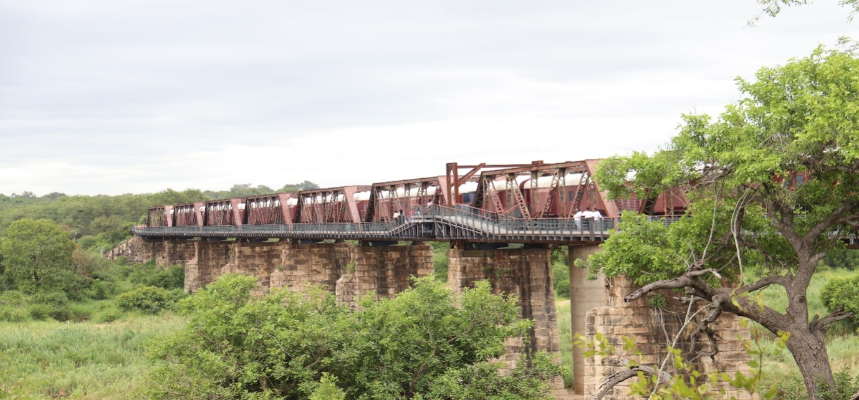

Baphinde bayiswa kwenye indawo ebizwa ngokuthi yiMdluli Safari Lodge okuyiloji ephethwe umphakathi wakhona eKruger National Park. Iloji lena ingaphansi kweNkosi uMdluli, esendaweni okuyimanje ibizwa ngokuthi yiMdluli Reserve esondelene nePaki. Le ndawo inamahektha alinganiselwa kumakhulu ayisishiyagalombili namashumi amahlanu angaphakathi eKruger Nationala Park. Umphakathi uba nemihlomulo oyitholayo ngokuba khona kwalamaloji esebenzayo ngaphakathi. Ukusebenza kwalama loji kunomfelandawonye lapho kuba nengxenye angamaphesenti angamashumi amahlanu atholwa umphakathi wakwaMdluli bese kuthi amanye kube ukuthi atholwa yilona okusetshenziswana naye. Inhloso yokuqala le loji kwakuwukuthuthukisa ingqalasizinda yomphakathi wakwaMdluli olinganiselwa kusibalo esizinkulungwane ezingamashumi amane nanhlanu ohlala ngaphansi kobuholi bakwaMdluli, kukhona izigodi ezine ngaphansi kobuholi bakwaMdluli.

Kuphindwe kwaqhutshekwa nohambo kwayiwa eBela Bela CPA etholakala esifundazweni saseLimpopo okuyilapho kubhekwe khona amaProjekthi ahlabahlosile aphethwe umphakathi waseBela Bela. IBela Bela CPA indawo yabasuswa etholakala eLimpopo ngaphansi komasipala waseBela Bela. Le ndawo yabasuswa ithathwa njengephumelele njengoba yabuyiselwa kubasuswa ngonyaka ka-1998. Njenkathi kuqedwa ukunikezwa umphakathi wakwaMabuela lo mhlaba, umphakathi waba nesiphakamiso sokuthi wenze izinto ngendlela ehlukile kweyejwayelekile njengoba manje sebendla izithelo zalokho. Phakathi kwezinto abazenza, ingxenye yomhlaba bakhanda kuyo iloji, indawo yezinkomo kanye nokutshala izihlahla, kanye nenye lapho bekhulisa khona izinkukhu kanye namaqanda. Lokho kwadala amathuba amaningi emisebenzi ahlomulisa imiphakathi.

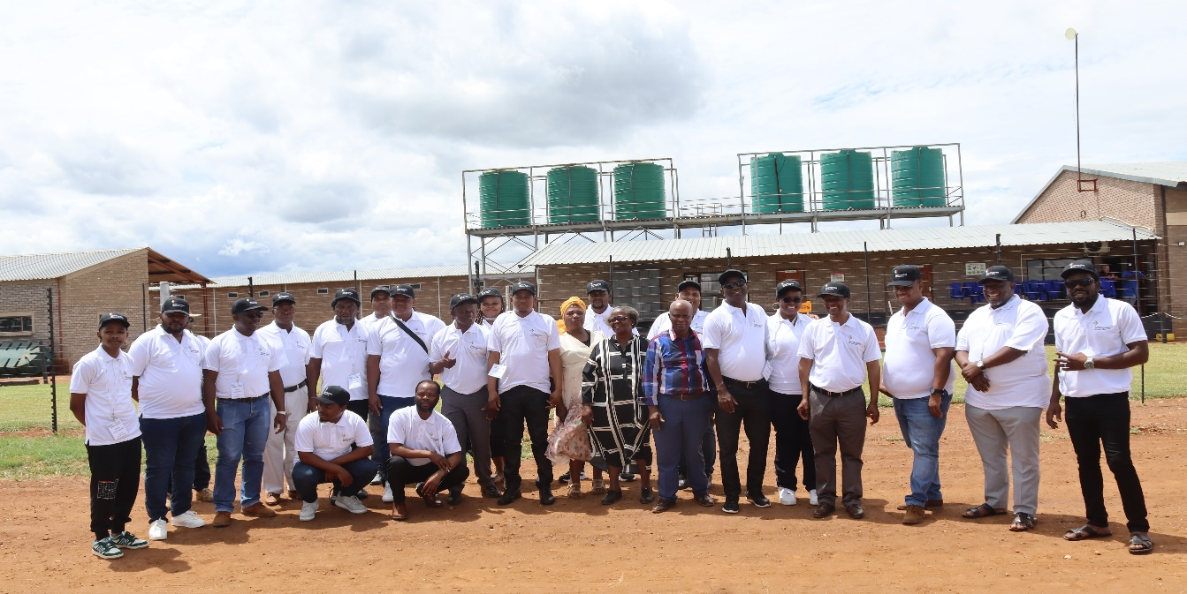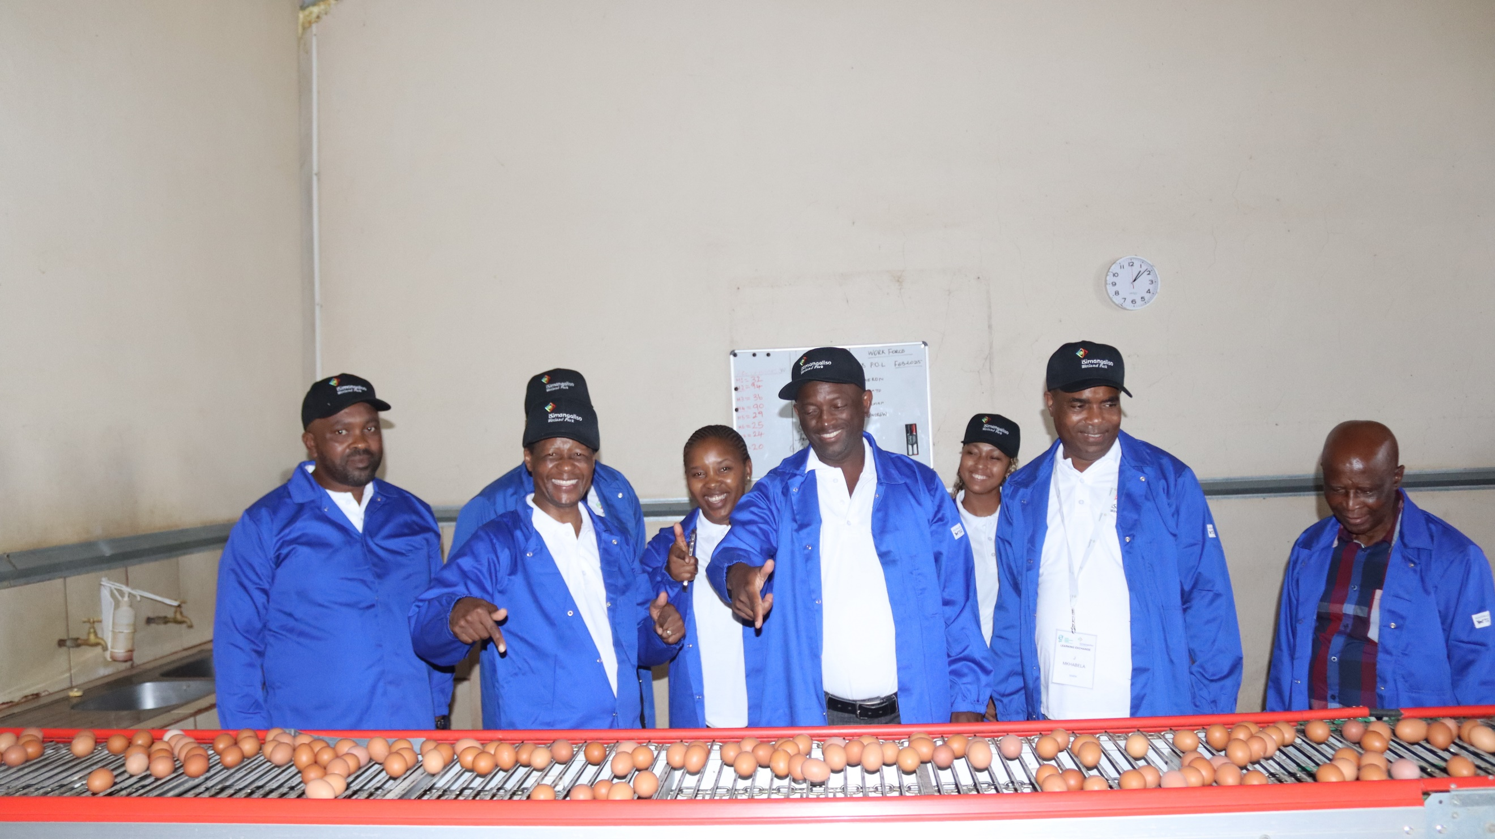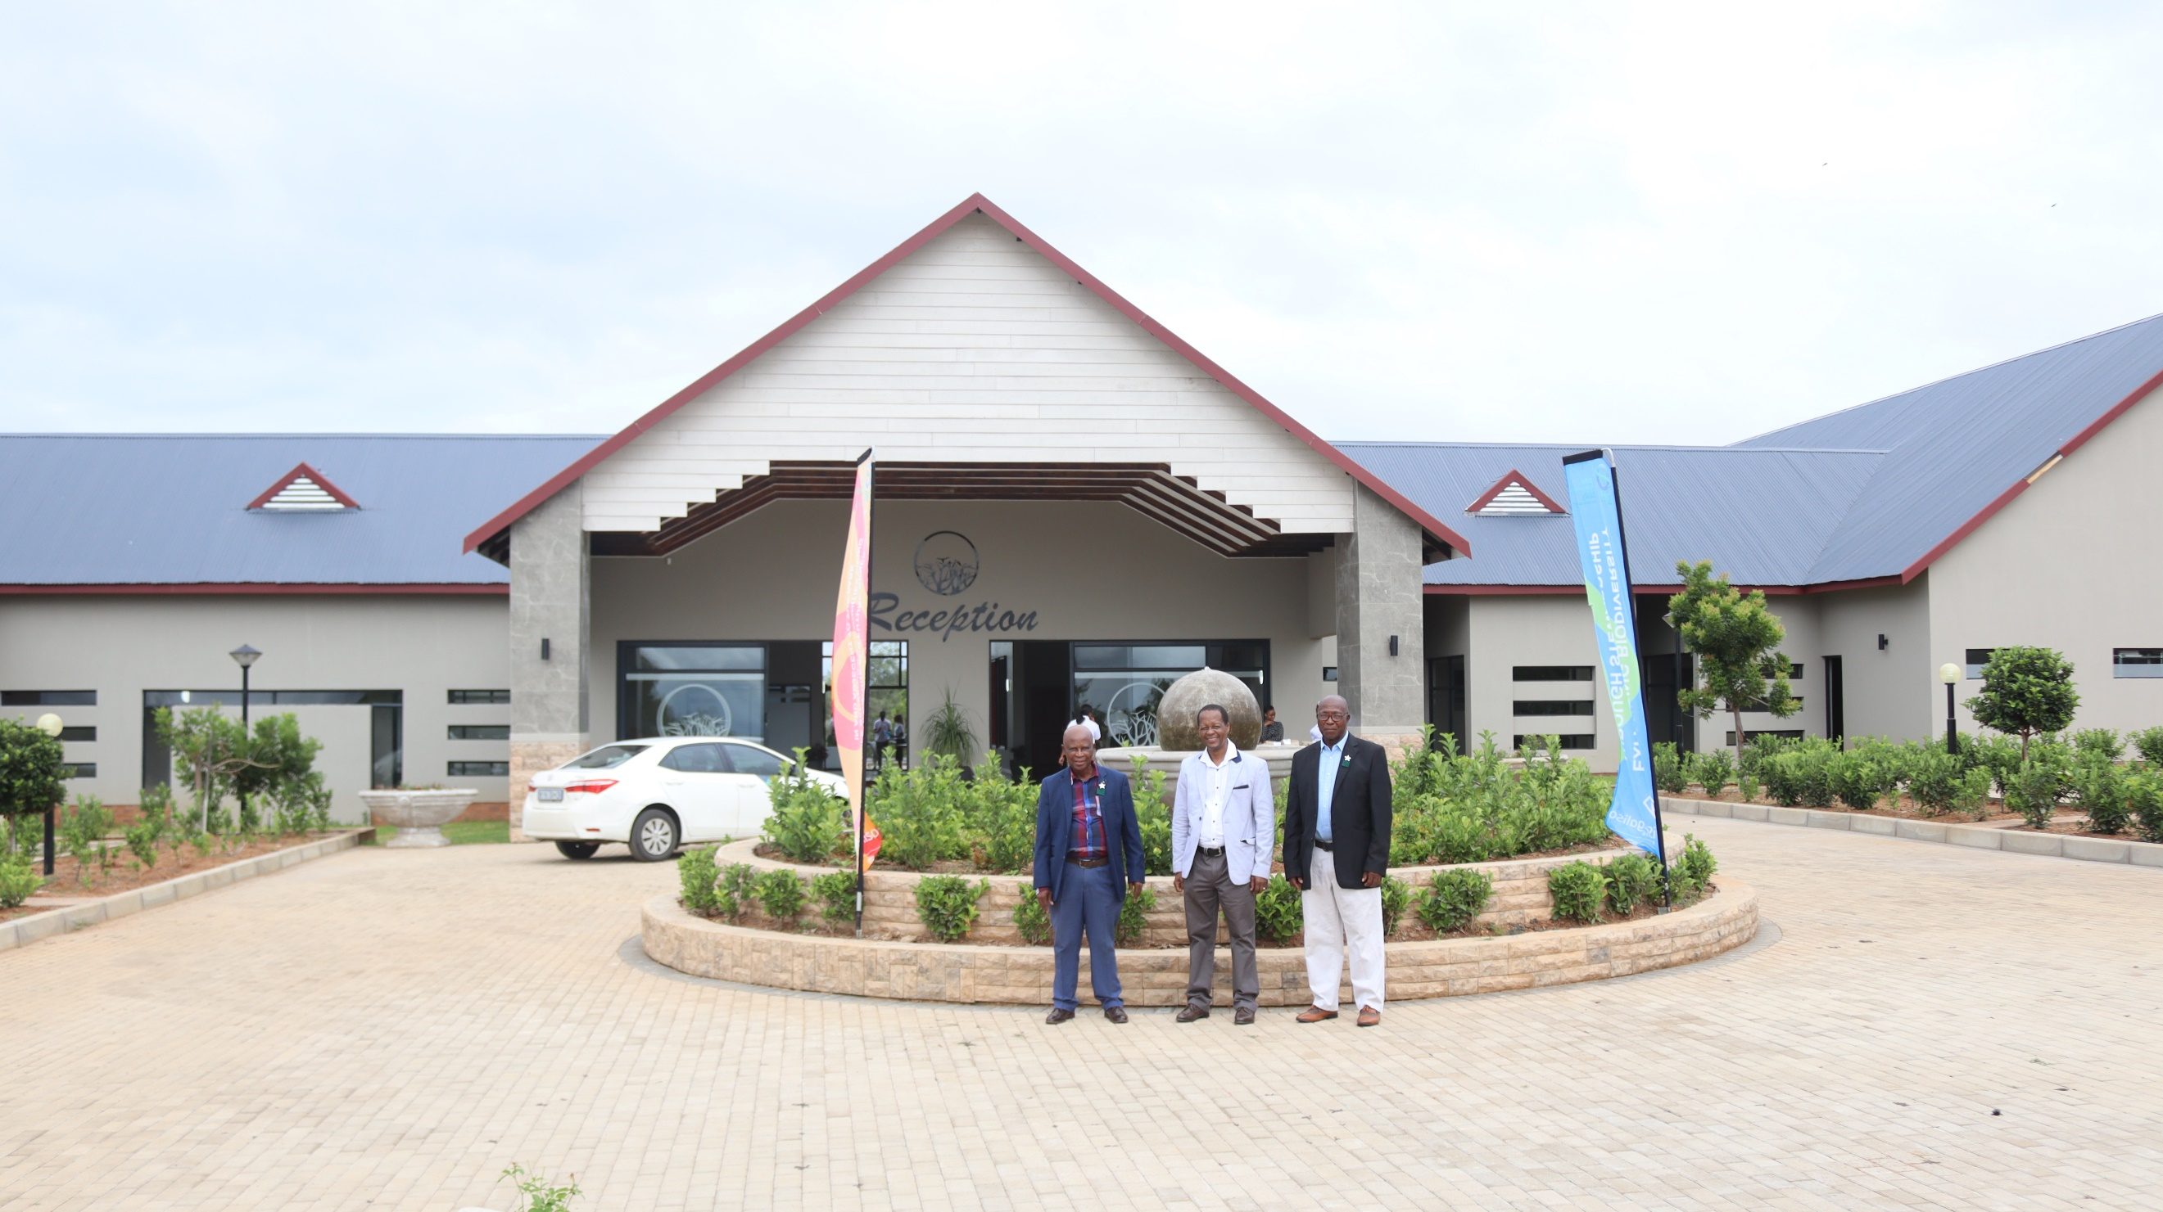

Amaqanda akhiqizwa lapha aqoqwa ndawonye, etakishwe kahle ngononina, bese ethengiswa ezitolo ezifana nePick n Pay, Shoprite kanye naseCheckers ukubala ezimbalwa. IBela Bela CPA ithathwa njengenomlando omuhle lapha eNingizimu Afrika uma kubhekwa udaba lokubuyiselwa komhlaba kubantu, futhi lokhu kusize kakhulu ukubuyisa isithunzi sabantu abahlwempu ababecindezelekile esikhathini saphambilini. Le-CPA inohlelo lapho umphakathi uthola khona imihlomulo, umuzi ngamunye uthola igqongo lempuphu eyigogogo, kube ihlukuza lezitshalo, inyama ebomvu/emhlopho okufaka phakathi nenyama yezilwane zasendle, amaqanda, ilayisi, kanye nenhlanzi njalo ngenyanga. Umphakathi uphinde uthole isipho sikancibijane okuyisamba sika-R10,000 umuzi ngamunye. Akugcini lapho ngoba kuphinde kube nezinhlelo lapho kuba namathuba anikezwa intsha ephuma ezikoleni ngoqeqesho ukuze ithole isipiliyoni. Kwabe sekuvakashelwa ezinye izindawo zezokuvakasha eziphethwe yilo mphakathi.

Usomlomo wendlu yobuholi bomdabu ngaphansi komkhandlu waseMkhanyakude, Inkosi Gumede, yazwakalisa ukubonga okukhulu kumphathi omkhulu weSimangaliso Wetland Park uMnuz. Bukhosini ukuba abaphe ithuba eliyingqayizivele lapho bebe nokuvuleka kwamehlo njengobuholi bendabuko. “Njengoba sibuka lokhu okwenziwa umphakathi waseBela Bela, ngaphansi kobuholi beNkosi uMabuela, ngicabanga ukuthi sisaselele ngemuva impela thina. Ngiyathokoza ngoba bonke abaholi bendabuko bakhona lapha, okumele sikwenze uma sibuyela emuva ukuthi siqhamuke namasu okuqala amabhizinisi ukuze kuzothuthuka imiphakathi esakhele.”

Umphathi omkhulu weSimangaliso Wetland Park Authority, uMnuz Sibusiso Bukhosini ngenkathi eba nesethulo kanye nabaholi bendabuko eLimpopo, waveza ukuthi abaholi bendabuko bengasebenzisana kanye nalabo abangongoti kulo mkhakha, kuningi okungazuzwa. “ngenkathi ngikhula ngangizwa kuthiwa uMkhandlu waseMkhanyakude unobuhlwempu obukhulu, kuze kube manje kusafana ubuhlwempu busakhona. Lokhu ngeke kuze kushintshe kuze kube ukuthi khona esikwenzayo. Uma iNkosi uMabuela ikwenzile, kusho ukuthi namakhosi aseMkhanyakude nawo engakwenza lokhu uma ezosebenzisana nezinhlaka zikahulumeni ezifana neSimangaliso Wetland Park Authority”.

Lokhu kucobelelsana ngolwazi kuza ngemuva kokuthi iSimangaliso sibe nomhlangano owathatha izinsuku ezine eHluhluwe kusuka ngomhlaka-10 kuya kumhlaka-13 kuMandulo nyakenye. Inhloso yalowo mhlangano kwakuwukujwayeza imiphakathi eyakhelene nePaki mayenala nenzuzo etholakala ngokuphathwa kwendawo evikelwe ngaphansi kwesiqubulo esithi kwakhiwa umnotho ngezindawo ezinemvelo ehlukahlukene ukuze kuthuthukiswe izimpilo zabantu*.* Phakathi kwezihambeli ezaziyingxeye yalowo mhlangano wanyakenye kubalwa onke aMakhosi aseMkhanyakude, abasuswa, uMnyango awakwaDFFE, SANBI, WWF, kanye neZemvelo KZN Wildlife, omasipala bangaphansi komkhandlu uMkhanyakude. Kwabe sekuhlelwa ukuthi kuvakashelwe eBela Bela ukuyobona ukuthi bona benza kanjani ukuthi abakwenzayo kuphumelele.

Isethulo esenziwa yiBela Bela saba neqhaza elikhulu ukudonsa amahlo abaholi bendabuko. Saba neminxa emibili lapho kwavezwa izinselelo kanye nezinkinga ezibhekene neSimangaliso. Phakathi kwezinkulumo, kwacaca ukuthi abantu abaningi bangabalimi/abafuyi, le ndawo abafuna ukuthi isetshenziswe iyasebenza ukuthi izinkomo zidle kuyo. Abantu banomdlandla wokuthi behlangane nom phathi omkhulu weBela Bela iNkosi uBarrington Mabuela ngenhloso yokufunda amasu angabasiza ukuze beqhubeke nokulima kodwa bephinde bebe neqhaza kulezi zinhlelo.

**-Iyaphela.-**

**Abezindaba bengaxhumana nokhulumela iSimangaliso Wetland Park:**

Mr Bheki Manzini

Call/Whatsap:060 533 2082

Email: bhekimanzini@isimangaliso.com